**Option 1: To connect Linux Instance using PuTTY**

1. Start PuTTY ( from the Start Menu, Click All Programs > PuTTY > PuTTY).
2. In the Category pane, select **Session** and complete the following filed:
   1. In the **Host Name** box, enter ec2-user@public_dns_name or IP.
   2. Under **Connection type**, select **SSH**.
   3. Ensure that **Port** is 22

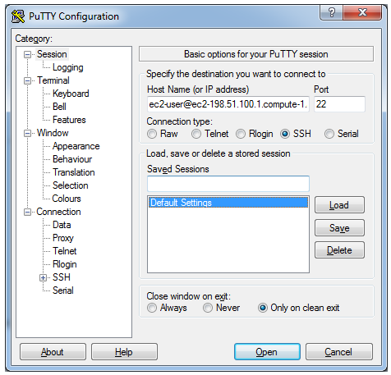

1. In the **Category** pane, expand **Connection,**  expand **SSH,** and then select **Auth.** Complete the following:
   1. Click Browse.
   2. Select the .ppk file that you generated for you key pair, then click Open.
   3. Click Open to start the PuTTY session.

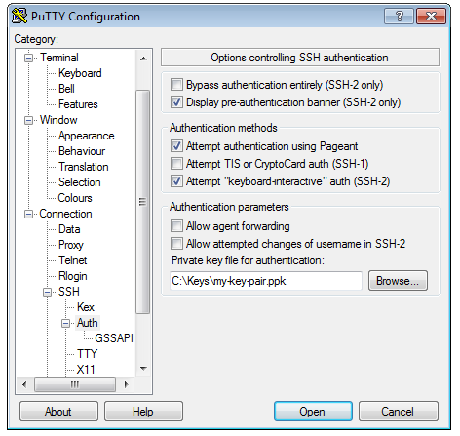

1. If this is the first time you have connected to this instance, PuTTY displays a securityy alert dialog box that tasks whether you truest the host you are conection to. Click **Yes**. A window opens and you are connected to your instances.

**Option 3: Connect from Mac or Linux Using an SSH Client**

Your Mac or Linux computer most likely includes an SSH client by default. You can check for an SSH client by typing ssh at the command line. If your computer doesn't recognize the command, the OpenSSH project provides a free implementation of the full suite of SSH tools. For more information, see

http://www.openssh.org.

Open your command shell and run the following command:

|  |
| --- |
| $ chmod 400 my-key-pair.pem |

Next, run the following command:

|  |
| --- |
| $ ssh -i /path/my-key-pair.pem ec2-user@public_dns_name |

**Tip**

For Amazon Linux, the user name is ec2-user. For RHEL5, the user name is either root or ec2-user. For Ubuntu, the user name is ubuntu. For Fedora, the user name is either fedora or ec2-user. For SUSE Linux, the user name is either root or ec2-user. Otherwise, if ec2-user and root don't work, check with your AMI provider.

**Add a Volume to Your Instance**

Now that you’ve launched and connected to your Linux instances, you can run the following command on your instance to view its mounted volumes.

|  |
| --- |
| [ec2-user@ip-172-31-52-202 ~]$ df -h |

For a micro instance, your output should look something like this.

|  |
| --- |
| [ec2-user@ip-172-31-52-202 ~]$ df -h  Filesystem Size Used Avail Use% Mounted on  /dev/xvda1 7.8G 1.2G 6.6G 15% /  devtmpfs 490M 56K 490M 1% /dev  tmpfs 499M 0 499M 0% /dev/shm  [ec2-user@ip-172-31-52-202 ~]$ |

The /dev/xvda1 volume is the root device volume. It contains the image used to boot the instance. Notice that there's some room to install additional software on your instance (only 15% of the file system is being used above). For example, you can use the yum command to download and install packages.

If you need additional storage for your data, a simple solution is to add Amazon EBS volumes to your instance. An Amazon EBS volume serves as network-attached storage for your instance. Let's add a volume to the Linux instance that you've launched. First we'll use the EC2 console to create the volume and attach it to the instance, and then we'll mount the volume to make it available.

**To create and attach an Amazon EBS volume**

1. Login to **AWS Console** and click EC2 **dashboard**, click **volume** , select **General Purpose (SSD),** size **1G** and make sure you have volume created on same **Available Zones** where EC2 instances is running and click **Create** .

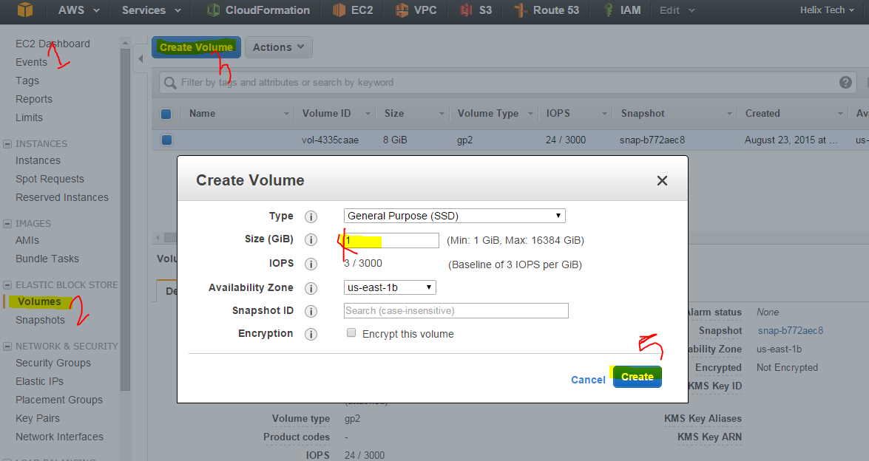

1. Once you created **Volume**, it’s ready attached to the instances now, to do that select newly created **volume** > **Action Volume** and select the **instance** , provides the **device** name and click **Attach**.

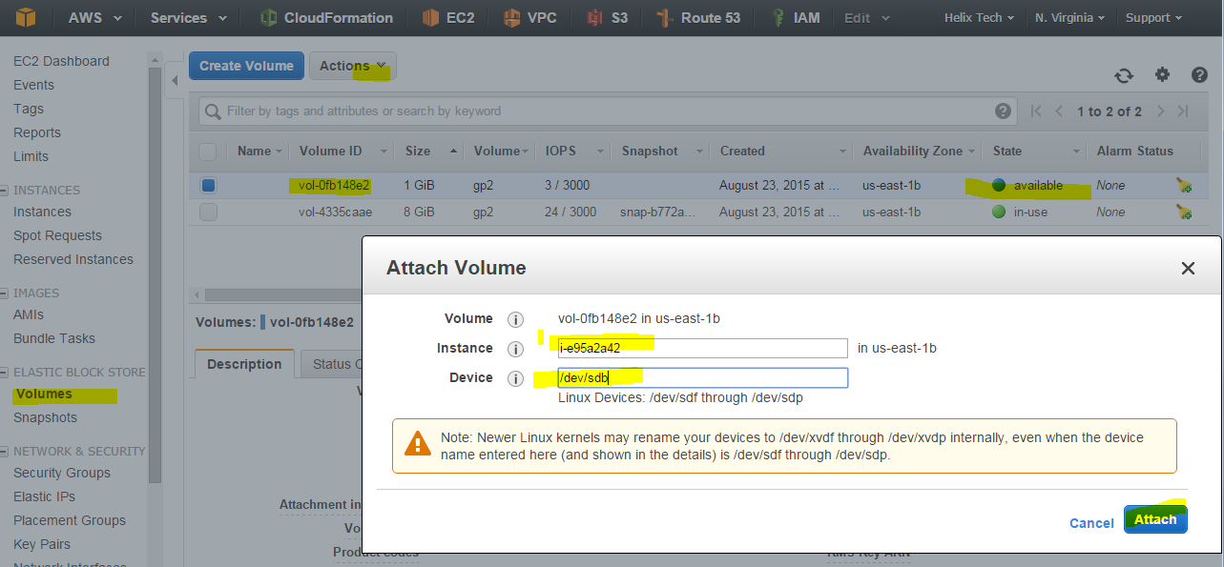

1. Once you attach the volume to the instances now volume state will be in use .

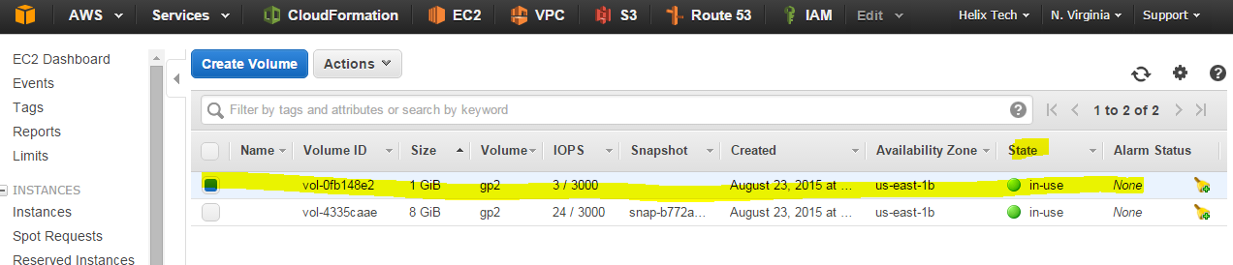

1. Now login to your instance using PuTTY or Linux Terminal and run the command “fdisk –l | grep Disk” to view the whether the newly created device attached or not. Below you can see the /dev/xvdb Disk which we created and attached to the instance.

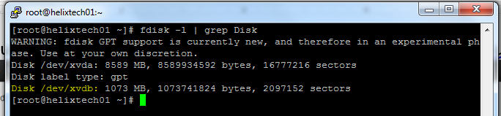

1. Now run the below command to create File system on the recently created volume.

|  |
| --- |
| [root@helixtech01 ~]# fdisk /dev/xvdb // To do Partitions run this command  Welcome to fdisk (util-linux 2.23.2).  Changes will remain in memory only, until you decide to write them.  Be careful before using the write command.  Device does not contain a recognized partition table  Building a new DOS disklabel with disk identifier 0xb5f08b67.  Command (m for help): n // To create new partition press ‘n’  Partition type:  p primary (0 primary, 0 extended, 4 free)  e extended  Select (default p): p // To make primary partition press ‘p’  Partition number (1-4, default 1): 1 // type ‘1’ or Hit enter to accept the default partition  First sector (2048-2097151, default 2048): < Hit Enter> // Hit Enter to accept the default size  Using default value 2048  Last sector, +sectors or +size{K,M,G} (2048-2097151, default 2097151): < Hit Enter> // Hit enter to accept the default  Using default value 2097151  Partition 1 of type Linux and of size 1023 MiB is set  Command (m for help): t // Press ‘t’ to change ‘**Hex code’**  Selected partition 1 // select partition # 1  Hex code (type L to list all codes): 8300 // Select 8300  Type of partition 1 is unchanged: Linux //  Command (m for help): w // Type ‘w’ to save and exit changes  The partition table has been altered!  Calling ioctl() to re-read partition table.  Syncing disks.  [root@helixtech01 ~]# fdisk -l /dev/xvdb // To verify you will see the ‘/dev/xvdb1’ below  Disk /dev/xvdb: 1073 MB, 1073741824 bytes, 2097152 sectors  Units = sectors of 1 * 512 = 512 bytes  Sector size (logical/physical): 512 bytes / 512 bytes  I/O size (minimum/optimal): 512 bytes / 512 bytes  Disk label type: dos  Disk identifier: 0xb5f08b67  Device Boot Start End Blocks Id System  /dev/xvdb1 2048 2097151 1047552 83 Linux  [root@helixtech01 ~]# |

1. Make a file system on the /dev/xvdb1

|  |
| --- |
| [root@helixtech01 ~]# mkfs.ext4 /dev/xvdb1  mke2fs 1.42.12 (29-Aug-2014)  Creating filesystem with 261888 4k blocks and 65536 inodes  Filesystem UUID: d955e3f3-4dd1-4ba8-92ea-c42e51744ef0  Superblock backups stored on blocks:  32768, 98304, 163840, 229376  Allocating group tables: done  Writing inode tables: done  Creating journal (4096 blocks): done  Writing superblocks and filesystem accounting information: done  [root@helixtech01 ~]# |

1. Create Mount point for the newly created EBS volume (/dev/sdb (/dev/xvdb)

|  |
| --- |
| [root@helixtech01 ~]# mkdir -p /sales  [root@helixtech01 ~]# |

1. Update the /etc/fstab file by adding below lines (use **vi** command to add the below line on /etc/fstab file .

|  |
| --- |
| # Additional File System  /dev/xvdb1 /sales ext4 defaults 0 0  Below are the /etc/fstab file after updating.. |

1. Run the ‘ mount -a’ command to mount the newly created FS system

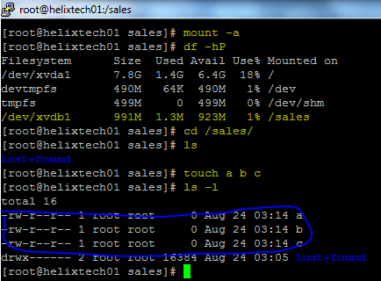

1. Congratulation! You are have completed adding additional EBS volume on and create File system on it and start using. Above example I create file name called **‘a, b and c’**
2. When you are done you can terminate the instances and clean up the EBS volume by executing below steps. Select the **Instance**, right click on **instances** > **Instance State** > **Terminate** or **Action** > **Instance State** > **Terminate**.

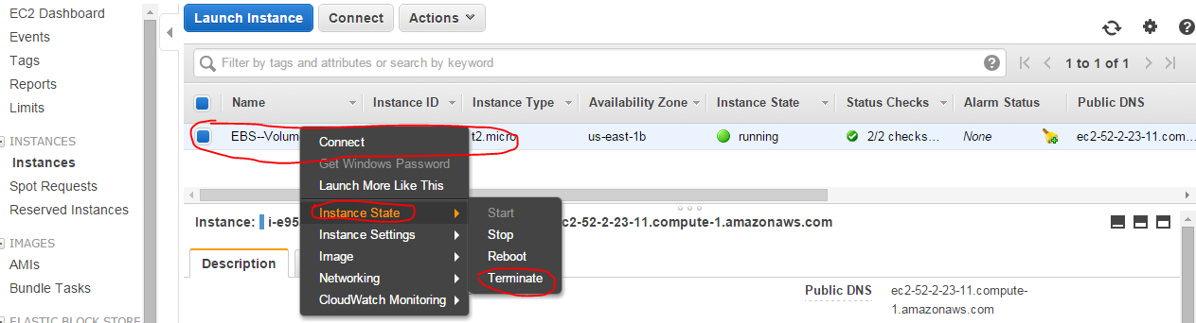

FYI

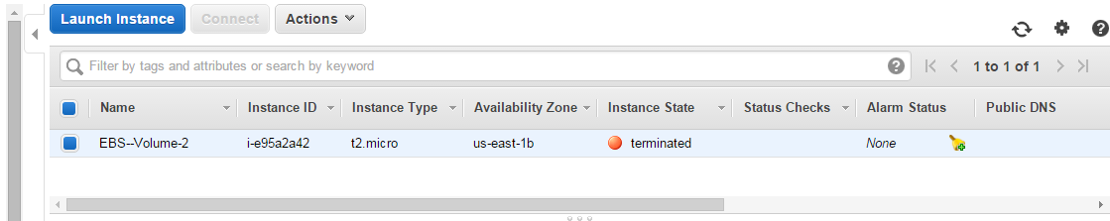

1. Now Clean up the EBS Volume to avoid getting charges or if you want to attached this EBS to other instances as well and all the files on the EBS will remain same ..

